Steps to install LocalExpress on Prestashop
- Download the LocalExpress Prestashop module
https://github.com/Localexpress/localexpress-prestashop
- Upload the LocalExpress plugin to the module directory
- Log in to the admin of your prestashop
- Go to the tab modules – modules and look for the localexpress module and click on ‘Install’ (under shipping and logistics)
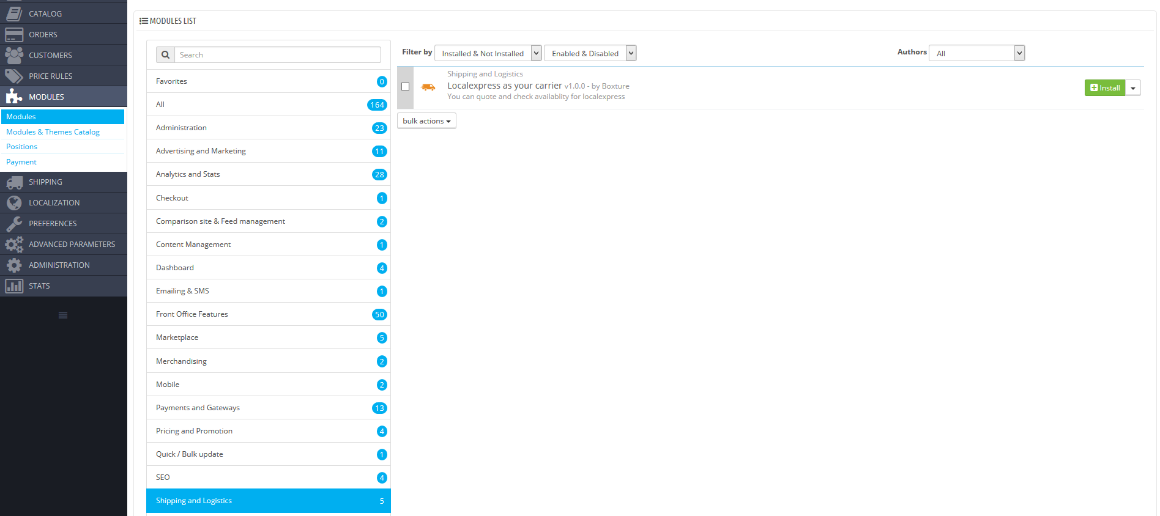
- As part of the installation guide the following information is required.